EXPERIMENT – 7
PREDICTING MODEL - LINEAR REGRESSION
Aim:
To perform salary prediction model using Linear Regression

Procedure:
1. Upload the given dataset.
2. Import all the necessities
3. Read through the dataset and make it as dataframe
4. Through sklearn train the model
5. Test the mode

Program:
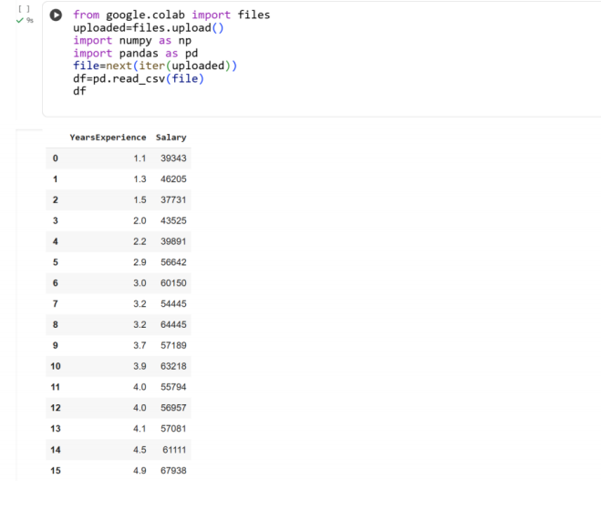
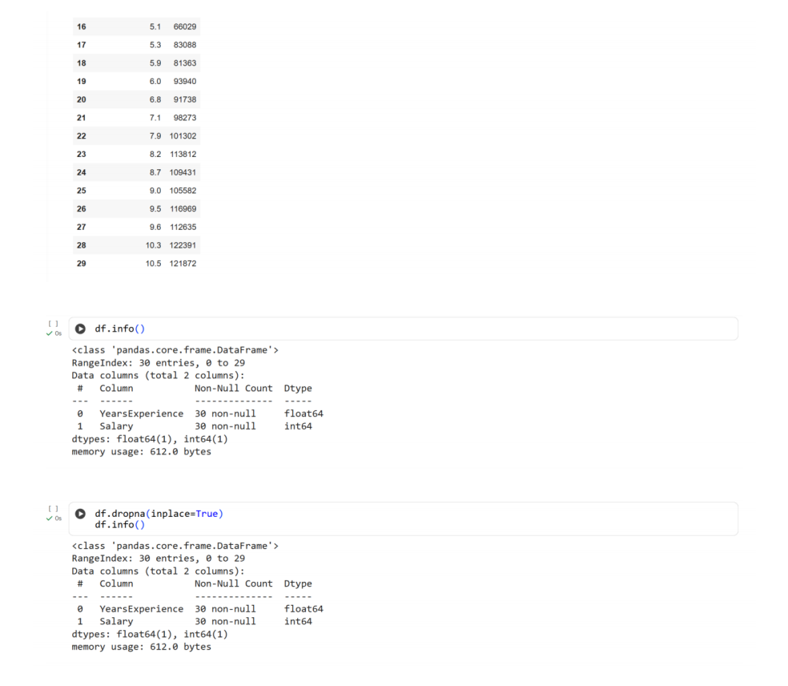
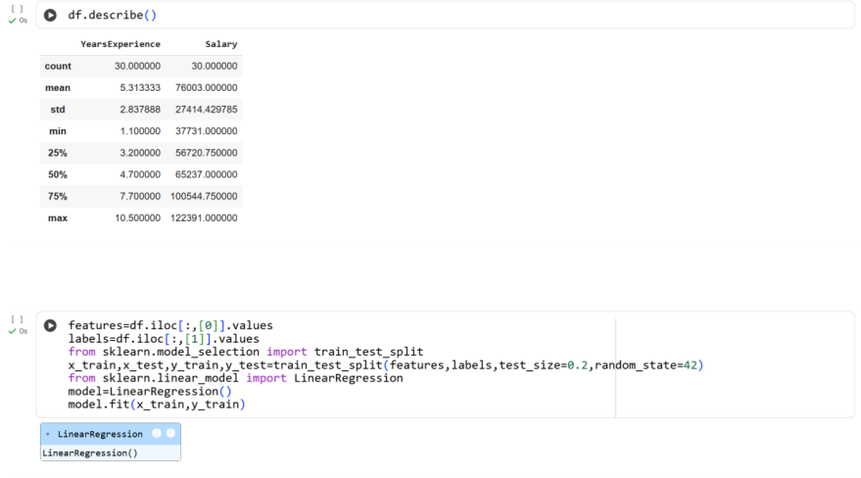
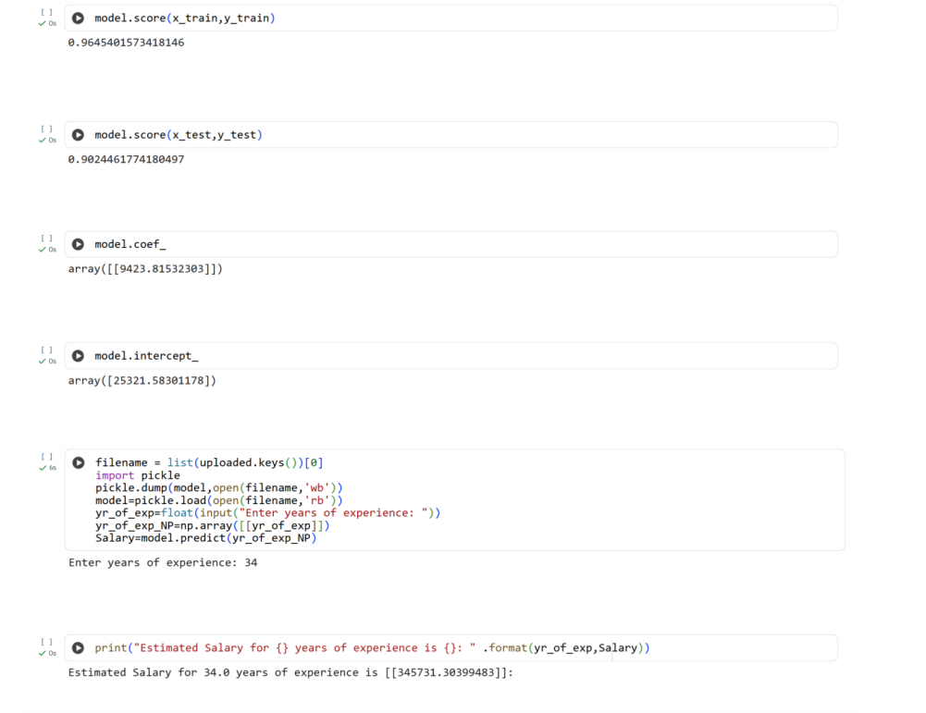
Result:
Thus the python program for predicting model using Linear Regression is executed and
verified

